Assignment Report: Big Data Analytics

Section 1 — Formulate Questions [10 marks]
- [10 marks] Formulate 3 questions that can only be explored through analysis and evaluation of the data. These should be presented in the form of questions which are not already answered within the data, but for which an answer may be arrived at through analysis and evaluation of the data answered. In each case provide some justification for why this is of interest. (300 words maximum)
Since emerging in 2019, COVID-19 has killed over 6,500,000 people worldwide [14]. Most vulnerable are the elderly and those with underlying health conditions [11-13].

Over 158,000 have died with COVID-19 in Indonesia alone [10]. Treatments and mitigations are, however, available. Therefore, ability to predict the progression and virulence of COVID is vital for enabling alleviation of the disease [20-22]. And, to reduce transmissions and hence mortality [29]. Establishing the relationship between death and case rates, as well as case fatality rate (CFR) and cumulative cases will thus be our priority [21], [22].

- Therefore, can our data reveal predictive insights into COVID-19 death and CFR at the national level?

Multiple studies indicate that the disease has a disproportionality negative impact in high population density areas [15], [16]. Urbanisation, too, with which density is intimately connected, is found to have propagated COVID-19 [17], [25]. Other studies however indicate that the opposite can be the case [26].
Hence, we wished to uncover spatial patterns in relation to cases, and Indonesia’s highly varied rates of density, urbanisation, and rurality [24]. This could help determine the allocation and planning of medical resources [16].
- Thus, have higher population densities and urbanisation served to drive COVID cases throughout Indonesia?
Cases began to surge at the end of May 2021 and into June amid the onset of the Delta variant in Indonesia [20]. The ensuing spike was the deadliest of the pandemic [10]. We wished to assess whether any combination of factors had predetermined a location’s likelihood of having higher relative case incidence just before the peak. Such classification could help ascertain where the health response should first be directed during future outbreaks [23], [24].
- Thus, can we meaningfully classify differences in relative case figures for specific locations just before rates skyrocketed amid Delta’s arrival?

Section 2 — Data Exploration & Preparation [20 marks]
Evidence for learning outcomes: LO2 Manipulate a data set to extract statistics and features
- [10 marks] Describe how you explored the data, with a clear rationale/justification and discuss any conclusions drawn from your exploration of the data. (300 words maximum)
We read through the 21,760 entries to familiarise ourselves with the data, which shows the progression of COVID through Indonesia, with a view to ascertaining how to tackle our research questions.

For Q1, we had determined the most important mortality indicators [21], [22]. We plotted these, first with national new cases per million against new deaths per million. We did this, since these are numerical values, whose relationship can be studied on a scatterplot [1]. A resulting fan-shaped plot (Figure 1) indicated a positive, linear association but with significant skew and outliers as revealed by a histogram [1]. We also plotted national CFR against total cases, observing positive relationship.

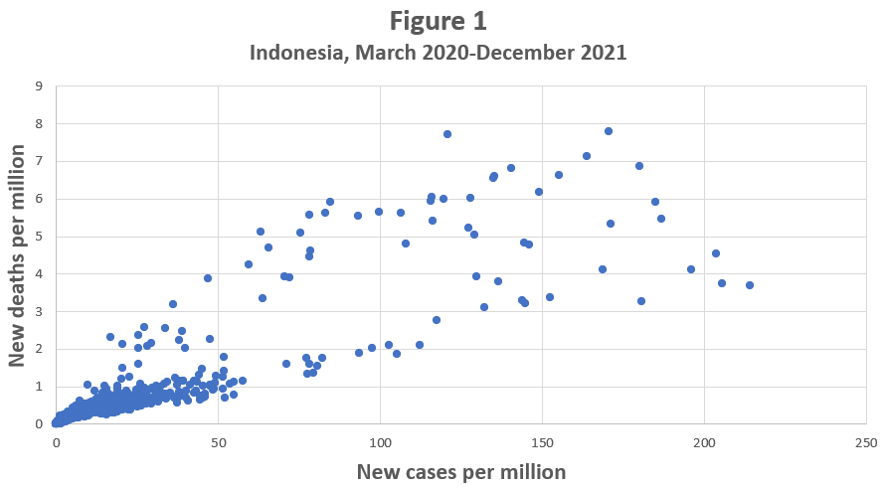

We used a scatter plot and coefficient to determine the relationship [1] between population density and total cases per million, since this was integral to Q2. We excluded Indonesia and compared combined data for the 34 locations, to obtain the most localised picture. We started from April 2020 because prior numerical data entry was irregular. A correlation of 0.42 indicated below moderate, positive correlation [1], [27]. Cumulative totals however indicated much stronger correlation. Jakarta, though, exerted large bias on the mean of 6,413.

We decided therefore to extract data for each location, one by one, to obtain the most precise data. Explorations revealed limited correlation between cases and settlement types.

For Q3, a scatter graph of cases versus time indicated one particularly large peak, starting at June-end, 2021, amid the onset of Delta [10]. We decided that May and June were the most important period to analyse since cases were on the verge of skyrocketing. Since higher density was a possible predetermining factor for earlier outbreak [18], we explored population density and urbanisation, seeing correlation, while also confirming that the islands themselves as nominal attributes could help classify caseloads [25].
- [10 marks] Describe all significant cleaning/pre-processing of the data that you carried out, with your rationale/justification. (300 words maximum)
We used Python to extract national data to analyse mortality [5], per Q1’s criteria. We log-10 transformed the data, making the linear relationship clearer on the graph [2], [7]. We observed ‘high leverage’ outliers at the start of all plots so removed these due to the irregular data collection before April 2020, which may have skewed its quality [1]. Early CFR data is often not considered of high quality [22], further justifying its removal.

For Q2, we extracted rows of data for each location individually, per our localised research criteria, programming changes into a csv file [5]. There were numerous missing values. In the case of DKI Jakarta, there were no Total Rural villages. We converted the spaces to 0 [6], [8], since the location comprises the world’s second-largest urban agglomeration [4].

We identified attributes pertinent to the research question, including population density, and deleted redundant columns. Thereafter we adhered to arff data rules to facilitate model building in WEKA [8]. We removed ‘location’ since its initial inclusion made the J48 decision tree overly complex.

We extracted relevant Q3 data for each location individually, after isolating the period of Delta’s onset [9]. We chose applicable attributes to answer our question, including ‘Island’ since this was key to the research [6].

We pre-processed a derived attribute indicating whether a location’s total cases per million was above or below the national monthly median for May or June respectively. The median was chosen because it is a robust statistic not skewed by outliers and gives us a midway point between the locations [1]. We also created J48 labels indicating whether daily Growth Factor of New Cases was below 1, or not, since 1 and above indicates an increase [34]. We would experiment in WEKA to see which worked best as a classificatory leaf node.

Python code snippet for data cleaning

import pandas as pd
# Read the CSV file
df = pd.read_csv(r'C:\Users\Price\Desktop\Q2SumateraOnlyTest.csv')
# 1. Remove rows with NaN values
# df = df.dropna()
# These next three lines of code replace empty space with NaN and then drop rows that contain NaN
# nan_value = float("NaN")
# df.replace("", nan_value, inplace=True)
# df.dropna(subset=["Growth Factor of New Cases"], inplace=True)
# Save the modified DataFrame back to a CSV file
# df.to_csv(r'C:\Users\Price\Desktop\Age.csv')
# 2. Remove rows with a specific value in a specific column
df.drop(df[df['j'] != "Sumatera"].index, inplace=True)
# Save the modified DataFrame back to the same CSV file, without an index column
df.to_csv(r'C:\Users\Price\Desktop\Q2SumateraOnlyTest.csv', index=False)

Section 3 — Data Analysis & Evaluation [40 marks]
Evidence for learning outcomes: LO3 Critically evaluate and apply data mining techniques/tools to build a classifier or regression model, and predict values for new examples
- [10 marks] Discuss the analysis techniques you have used to address each of your questions, with some rationale/justification for each key decision made. (300 words maximum)
To build a predictive model for death rates against case rates we chose linear regression, since the values are both numeric [8]. This will give us a clearly understandable visualisation of any relationship and a linear equation for predicting future values [8]. A separate plot of the residuals will establish any nonlinearity [1].

Since the relationship between CFR and total cases was found to be nonlinear during exploration, we would apply SMOreg [8]. We would also plot CFR against time to observe any irregularities [22].

For Q2, we opted for multiple linear regression since we were attempting to find possible connection between several, independent numerical variables, and a single output [8], [1]. Because attributes can be removed in WEKA, we took a stepwise, forward selection approach [1]. This would help us establish which factors, including population density and levels of urbanisation, could help build a predictive model for case rates. We would be using the correlation coefficient and root mean squared error as exploratory guides [8], [28].

For Q3, we built a J48 classifier to determine whether several numerical and nominal attributes had pre-determined case distribution amid Delta’s onset [27]. Some attributes grow in influence when combined, which a tree helps ascertain and visualise [8]. Decision trees also prune any values that offer no correlative value, making them efficient for experimentation.

Because the ‘Islands’ category was crucial [25] and decision trees are designed to deal with nominal attributes, and are robust to outliers, we chose these as potential nodes [27].

Our binary attribute regarding whether a location was above or below the national monthly median case rate, suits classifiers and ensures easy-to-read leaves [8]. J48 can help us determine whether this or GFNC status is best for classifying COVID hotspots [8], [34]. Sustained GFNC increases above 1 indicate exponential growth.
- [10 marks] Provide a general summary of the results of your analysis. (300 words maximum)
Linear regression for Q1, part 1, with a percentage split of 66 [8], yielded a correlation coefficient of 0.95, giving us positive association (Figure 2).

The following equation was generated for subsequent values:

Log_new_deaths_per_million =

0.84 * Log_new_cases_per_million +
-1.29

A mean absolute error of 0.1472 indicates that values of predicted new death rates are within a range of roughly plus/minus that figure. A relative absolute error of 32 percent connotes a moderately accurate model. However, a plot of the residuals indicated imperfect linearity albeit not at a level that undermines the model (Figure 2 Supplement.).

For Q1, part 2, the mean CFR for the non-log data was 0.04 with standard deviation of 0.02. A nonlinear scatterplot shows an initially flat relationship, with CFR well above the mean as case numbers build. However, it turns negative overall, with SMOreg returning correlation of 0.90 and a negative equation for the weight.

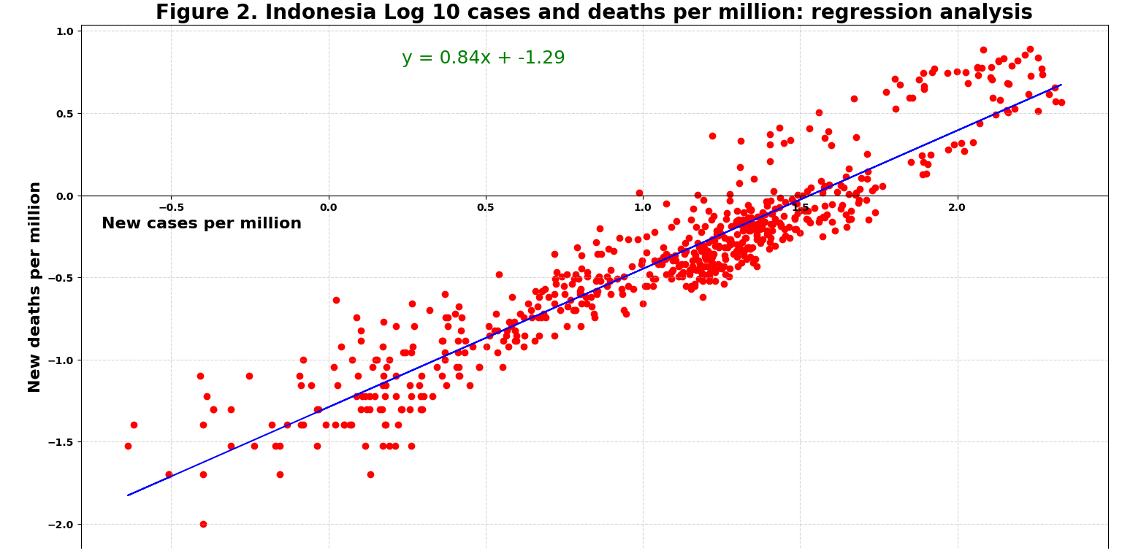

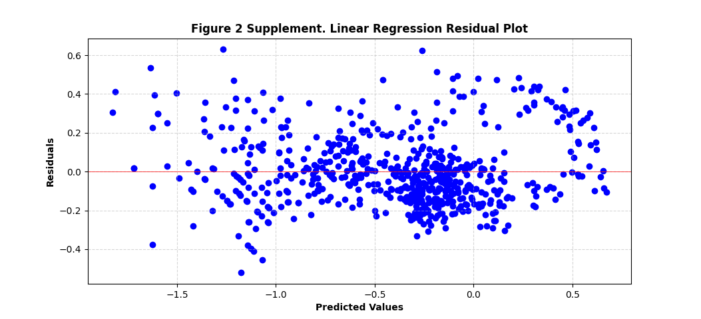

Python code snippets for production of Figure 2. Linear regression, and Residuals supplement

import pandas as pd
import matplotlib.pyplot as plt
from sklearn.linear_model import LinearRegression
# Load the data from the Excel file
data = pd.read_excel(r'C:\Users\Price\OneDrive\Desktop\Q1Part1Regression.xlsx', sheet_name='Sheet1')
# Split the data into independent and dependent variables
x = data.iloc[:, 0].values.reshape(-1, 1) # Independent variable
y = data.iloc[:, 1].values.reshape(-1, 1) # Dependent variable
# Perform linear regression analysis
regressor = LinearRegression()
regressor.fit(x, y)
# Adjust figure size
fig, ax = plt.subplots(figsize=(12, 10))
# Plot the data points and regression line
plt.scatter(x, y, color='red')
plt.plot(x, regressor.predict(x), color='blue')
# Add grids
plt.grid(True, linestyle='--', alpha=0.5)
# Adjust x-axis position and label
plt.axhline(0, color='black', linewidth=0.5) # Horizontal line at y=0
plt.gca().spines['bottom'].set_position(('data', 0)) # Move x-axis to y=0
plt.xlabel('New cases per million', fontweight='bold', fontsize=16, x=0.02, y=-0.12, ha='left')
# Above, set x-axis label inside the y-axis and to the left
plt.title('Figure 2. Indonesia Log 10 cases and deaths per million', fontweight='bold', fontsize=20)
plt.ylabel('New deaths per million', fontweight='bold', fontsize=16)
plt.xticks(fontweight='bold')
plt.yticks(fontweight='bold')
# Display the regression formula with larger font size
m = regressor.coef_[0][0]
b = regressor.intercept_[0]
formula = f'y = {m:.2f}x + {b:.2f}'
plt.text(max(x)*0.1, max(y)*0.9, formula, fontsize=18, color='green') # Adjusted coordinates and larger font size
plt.tight_layout()
plt.show()
# Obtain the predicted values
y_pred = regressor.predict(x)
# Calculate residuals
y_pred = regressor.predict(x)
residuals = y - y_pred
# Plot the residuals
plt.scatter(y_pred, residuals, color='blue')
plt.axhline(0, color='red', linewidth=0.5) # Horizontal line at y=0
# Add grids
plt.grid(True, linestyle='--', alpha=0.5)
# Set plot title and labels
plt.title('Figure 2 Supplement. Linear Regression Residual Plot', fontweight='bold')
plt.xlabel('Predicted Values', fontweight='bold')
plt.ylabel('Residuals', fontweight='bold')
plt.show()

For Q2, linear regression of population density against case rates yields correlation of 0.43 for Indonesia, hinting at a weak positive relationship [27]. Multiple regression yielded stronger but moderate correlation of 0.46.

The following equation indicates the variables that created the strongest model:

Total_Cases_per_Million =

-1.0759 * Total_Urban_Villages +
-0.7152 * Total_Rural_Villages +
1.5535 * Population_Density +
7111.9662

A relative absolute error of 93 percent means this is an inaccurate model for case predictions. Regression analysis for individual islands, however, often returns stronger results.
Our Q3 decision tree correctly classified 87 percent of the selected instances, meaning 13 percent were incorrectly classified. A Kappa statistic of 0.74 suggests strong agreement between predicted and observed classifications [8]. A relative absolute error of 47 percent indicates accuracy of some 53 percent, suggesting usability for further analysis but unreliability as a classifier.
The tree (Figure 3, produced with WEKA) has a size of 20 with 13 leaves, and a relatively low false positive rate of 0.13 [8].

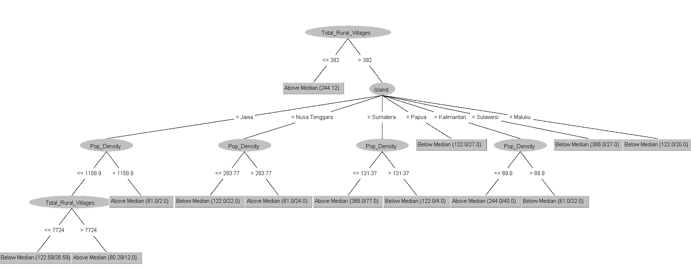
Figure 3, J48 decision tree for Research Question 3

- [10 marks] What do the results say in response to each of your 3 questions? (300 words maximum)
Since correlation does not necessarily equal causation [27], there is only evidence, not proof of causation for Q1, part 1. The linear equation linking COVID, and mortality could however be used to calculate death rates if COVID continued to rise slightly. However, extrapolating too far would be invalid because more accumulated cases would eventually indicate numerous reinfections. Overall, our findings invite further investigation of mortality using additional independent variables including vaccines.

Our CFR model is a starting point for mortality analysis but requires contextualisation using events and supplementary variables [29]. It isn’t useful for concrete predictions, even of trends.

Q2’s multiple regression suggests that increases in national case rates are linked to a combination of higher population densities and lower village numbers but not to urbanisation per se. However, correlation is modest and error scores high, meaning this is statistically inconclusive.

Moreover, the relationship was predicated on the skewing effect [1] of DKI Jakarta’s population density (Figure 4). Without Java where Jakarta is located, correlation falls to an almost meaningless 2.1. However, this skew was tolerated [1] since it reveals the densely populated island’s role as a major COVID hotspot. Indeed, Java is a central vector for national transmission [25].

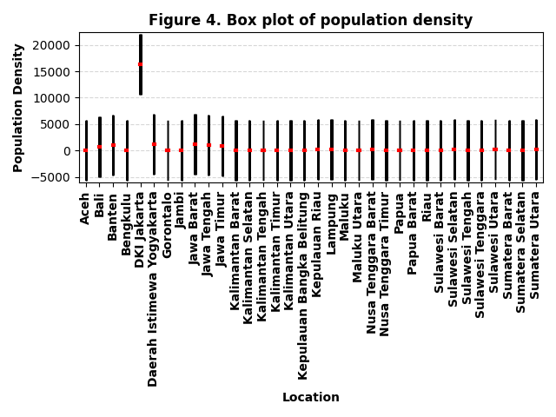

Python code for Figure 4. Box Plot

import pandas as pd
import matplotlib.pyplot as plt
# Data
data = {
'Location': ['Aceh', 'Bali', 'Banten', 'Bengkulu', 'DKI Jakarta', 'Daerah Istimewa Yogyakarta', 'Gorontalo',
'Jambi', 'Jawa Barat', 'Jawa Tengah', 'Jawa Timur', 'Kalimantan Barat', 'Kalimantan Selatan',
'Kalimantan Tengah', 'Kalimantan Timur', 'Kalimantan Utara', 'Kepulauan Bangka Belitung',
'Kepulauan Riau', 'Lampung', 'Maluku', 'Maluku Utara', 'Nusa Tenggara Barat', 'Nusa Tenggara Timur',
'Papua', 'Papua Barat', 'Riau', 'Sulawesi Barat', 'Sulawesi Selatan', 'Sulawesi Tengah',
'Sulawesi Tenggara', 'Sulawesi Utara', 'Sumatera Barat', 'Sumatera Selatan', 'Sumatera Utara'],
'Value': [90.54, 729.43, 1109.64, 100.38, 16334.31, 1158.9, 104.88, 69.79, 1276.55, 1108.64, 846.78, 36.81,
103.84, 16.74, 27.52, 8.59, 84.01, 235.24, 262.7, 39.37, 40.89, 283.77, 111.07, 13.6, 11.08, 69.8,
92.93, 201.78, 47.79, 69.23, 190.17, 131.37, 89.72, 203.82]
}
# Create DataFrame
df = pd.DataFrame(data)
# Create figure and axes
fig, ax = plt.subplots()
# Create empty list to store individual box plots
box_plots = []
# Iterate over each location and create a box plot
for i, location in enumerate(df['Location']):
location_data = df.loc[df['Location'] == location, 'Value']
box = ax.boxplot(location_data, positions=[i + 1], patch_artist=True, notch=True,
boxprops={'linewidth': 50, 'facecolor': 'lightblue', 'edgecolor': 'black'},
medianprops={'linewidth': 3, 'color': 'red'})
box_plots.append(box)
# Set x-axis tick locations and labels
ax.set_xticks(range(1, len(df) + 1))
ax.set_xticklabels(df['Location'], rotation=90, fontweight='bold')
# Customise plot
ax.set_ylabel('Population Density', fontweight='bold')
ax.set_xlabel('Location', fontweight='bold')
ax.set_title('Figure 4. Box plot of population density', fontweight='bold')
# Add horizontal grid lines
ax.yaxis.grid(True, linestyle='--', alpha=0.5)
# Set y-axis limits with extra space below
y_min = df['Value'].min() - 6000
y_max = df['Value'].max() + 6000
ax.set_ylim(y_min, y_max)
# Adjust layout
plt.tight_layout()
# Show plot
plt.show()

For Q3, the median score was a statistically significant leaf node; GFNC wasn’t.

J48 shows that as Delta arrived, fewer rural villages tended to indicate above-median case rates, giving a useful split. However, population density yielded mixed results. Albeit on the key island of Java higher density did indicate above-median cases. ‘Total cities’ proved irrelevant.

The islands are a meaningful splitting point as the literature predicted. But even on Java, more rural villages didn’t always equal lower cases, indicating mixed classification. Thus, we can partially answer in the affirmative: several non-arbitrary classifications did emerge. Error scores were too high for concrete prediction.

Report References
[1] D.M. Diez, C. D. Barr and M. Çetinkaya-Rundel, OpenIntro Statistics, Place of publication not identified: OpenIntro, 2019.
[2] A. Gelman, "You should (usually) log transform your positive data", Statmodeling.stat.columbia.edu, 21 Aug 2019. [Blog Entry]. Available: https://statmodeling.stat.columbia.edu/2019/08/21/you-should-usually-log-transform-your-positive-data/ [Accessed 3 October 2022].
[3] D.M. Lane (date of publication not identified). “Online Statistics Education: An Interactive Multimedia Course of Study”, onlinestatbook, developed by Rice University (Lead Developer), University of Houston Clear Lake, and Tufts University [Online]. Available: https://onlinestatbook.com/2/transformations/log.html [Accessed 3 October 2022].
[4] R. Martinez and I.N. Masron. “Jakarta: A city of cities.” ncbi.nlm.nih.gov, 21 Aug 2020. [Online]. Available: https://www.ncbi.nlm.nih.gov/pmc/articles/PMC7442427/ [Accessed 5 October 2022].
[5] W. McKinney, Python for Data Analysis, 3rd Edition. wesmckinney.com, Aug 2022. [E-book]. Available: wesmckinney.com/book/ [Accessed 5 October 2022].
[6] D. Cielen, A. D. B. Meysman, and M. Ali, Introducing data science big data, machine learning, and more, using Python tools, Greenwich: Manning, 2016
[7] K. Anderson, et al., (2004, exact date of publication not specified), Math Review: Useful Math for Everyone, University of Minnesota, School of Public Health [Online]. Available: mclph.umn.edu/mathrefresh [Accessed 5 October 2022].
[8] I. H. Witten, et al., Data Mining: Practical Machine Learning Tools and Techniques, Cambridge, MA: Elsevier Science & Technology, 2016.
[9] O. Dyer. “Covid-19: Indonesia becomes Asia’s new pandemic epicentre as delta variant spreads.” bmj.com, 16 July 2021. [Online]. Available: https://www.bmj.com/content/374/bmj.n1815 [Accessed 5 October 2022].
[10] WHO Coronavirus (COVID-19) Dashboard for Indonesia (No date specified, ongoing). World Health Organisation [Online]. Available: https://covid19.who.int/region/searo/country/id [Accessed: 06 October 2022].
[11] M. Nouri-Vaskeh, A. Sharifi, N. Khalil, and A. Sharifi., “Dyspneic and non-dyspneic (silent) hypoxemia in COVID-19: Possible neurological mechanism.” ncbi.nlm.nih.gov, 09 Sep 2020. [Online]. Available: ncbi.nlm.nih.gov/pmc/articles/PMC7480672/#bib0110 [Accessed: 06 October 2022].
[12] J.M. Bartleson, et al., SARS-CoV-2, COVID-19 and the Ageing Immune System. Nat Aging, ncbi.nlm.nih.gov, 14 Sep 2021. [Online]. Available: https://www.ncbi.nlm.nih.gov/pmc/articles/PMC8570568/ [Accessed: 06 October 2022].
[13] CDC, COVID-19 Vaccines for People Who Are Moderately or Severely Immunocompromised, cdc.gov [Online]. Available: https://www.cdc.gov/coronavirus/2019-ncov/vaccines/recommendations/immuno.html [Accessed: 06 October 2022].
[14] WHO Coronavirus (COVID-19) Dashboard for World. (No date specified, ongoing) World Health Organisation [Online]. Available: https://covid19.who.int/ [Accessed: 06 October 2022].
[15] P.R. Martins-Filho, “Relationship between population density and COVID-19 incidence and mortality estimates: A county-level analysis,” ncbi.nlm.nih.gov, 03 Jul 2021. [Online]. Available: https://www.ncbi.nlm.nih.gov/pmc/articles/PMC8253654/ [Accessed: 06 October 2022].

[16] S. Kodera, E.A. Rashed, and A. Hirata. “Correlation between COVID-19 Morbidity and Mortality Rates in Japan and Local Population Density, Temperature, and Absolute Humidity,” ncbi.nlm.nih.gov, 29 Jul 2020. [Online]. Available: https://www.ncbi.nlm.nih.gov/pmc/articles/PMC7432122/ [Accessed: 06 October 2022].

[17] M.K. Gurram, M.X. Wang, and Y.C. Wang., “Impact of urbanisation and environmental factors on spatial distribution of COVID-19 cases during the early phase of epidemic in Singapore,” nature.com, 13 June 2022. [Online]. Available: https://www.nature.com/articles/s41598-022-12941-8 [Accessed: 06 October 2022].

[18] F. Carozzi, S. Provenzano, and S. Roth, “Urban Density and Covid-19,” cep.lse.ac.uk, 17 Aug 2020 [Online]. Available: https://cep.lse.ac.uk/pubs/download/dp1711.pdf [Accessed: 06 October 2022].

[19] H. Beech and L. Albeck-Ripka, “As Delta Variant Surges, Outbreaks Return in Many Parts of the World,” nytimes.com, 30 June 2021. [Online]. Available: https://www.nytimes.com/2021/06/30/world/asia/virus-delta-variant-global.html [Accessed: 06 October 2022].

[20] O. Dyer, “Covid-19: Indonesia becomes Asia’s new pandemic epicentre as delta variant spreads.” bmj.com, 16 July 2021. [Online]. Available: https://www.bmj.com/content/374/bmj.n1815 [Accessed: 06 October 2022].

[21] D V Melik-Huseynov, et al., “Regression Models Predicting the Number of Deaths from the New Coronavirus Infection,” ncbi.nlm.nih.gov, 2020, full date of publication not disclosed. [Online]. Available: https://pubmed.ncbi.nlm.nih.gov/34513048/ [Accessed: 05October 2022].
[22] B.S. Thomas, N.A. Marks, “Estimating the case fatality ratio for COVID-19 using a time-shifted distribution analysis,” ncbi.nlm.nih.gov, Jul 19, 2021. [Online]. Available: https://www.ncbi.nlm.nih.gov/pmc/articles/PMC8438516/ [Accessed: 06 October 2022].

[23] J. Raymond. “The lag between daily reported Covid-19 cases and deaths and its relationship to age,” ncbi.nlm.nih.gov, Mar 9, 2021. [Online]. Available: https://pubmed.ncbi.nlm.nih.gov/33709641/ [Accessed: 08 October 2022].

[24] healthdata.org, “COVID-19 Results Briefing Indonesia July 18, 2022,” 18 Jul 2022. [Online]. Available: https://www.healthdata.org/sites/default/files/files/Projects/COVID/2022/11_briefing_Indonesia_7.pdf [Accessed: 10 October 2022].

[25] M.A. Widiawaty, K.C. Lam, M. Dede, and N.H. Asnawi, “Spatial differentiation and determinants of COVID-19 in Indonesia,” bmcpublichealth.biomedcentral.com, 23 May 2022. [Online]. Available: https://bmcpublichealth.biomedcentral.com/articles/10.1186/s12889-022-13316-4 [Accessed: 12 October 2022].

[26] Johns Hopkins Bloomberg School of Public Health, “Study: Urban Density Not Linked to Higher Coronavirus Infection Rates — and Is Linked to Lower COVID-19 Death Rates,” (2020, June. 18), publichealth.jhu.edu, [Online]. Available: https://publichealth.jhu.edu/2020/urban-density-not-linked-to-higher-coronavirus-infection-rates-and-is-linked-to-lower-covid-19-death-rates [Accessed: 07 October 2022].

[27] J. D. Kelleher, and B.Tierney, Data Science, Cambridge, Massachusetts: The MIT Press, 2018

[28] A. Kumar, R. McCann, J. Naughton, J.M. Patel, “Model Selection Management Systems: The Next Frontier of Advanced Analytics”, dl.acm.org, Dec 2014, full date of publication not disclosed. [Online]. Available: https://dl.acm.org/doi/pdf/10.1145/2935694.2935698?casa_token=oIbnt42FGnAAAAAA:diPCN1gXD6jrazSLzOGPdnRmSgXpsditZz07RppuKHss9Z7jJk8WkI4lwRinXFgwvlOSN3HBiPc [Accessed: 11 October 2022].

[29] E. Mathieu, et al., “Mortality Risk of COVID-19,” ourworldindata.org, 2020, full date of publication not disclosed. [Online]. Available: https://ourworldindata.org/mortality-risk-covid [Accessed: 12 October 2022].

[30] M. Miftahussurur, et al., “Lessons from Indonesia, a country with highest COVID-19 mortality rate in the world: dissecting multiple aspects”, f1000research.com, 10 Aug 2022, [Online]. Available: https://f1000research.com/articles/11-920#ref14 [Accessed: 13 October 2022].

[31] J. Kurlantzick, “Indonesia Finally May Have Turned a Corner on COVID-19”, cfr.org, 30 Sept 2021, [Blog entry]. Available: https://www.cfr.org/blog/indonesia-finally-may-have-turned-corner-covid-19 [Accessed: 13 October 2022].

[32] Y. Alimohamadi, H. Hailu Tola, A. Abbasi-Ghahramanloo, M. Janani, M. Sepandi, “Case fatality rate of COVID-19: a systematic review and meta-analysis”, pubmed.ncbi.nlm.nih.gov, 30 Jul 2021. [Online]. Available: https://pubmed.ncbi.nlm.nih.gov/34604571/ [Accessed: 13 October 2022].

[33] A. Sahasranaman and H.J. Jensen, “Spread of COVID-19 in urban neighbourhoods and slums of the developing world”, royalsocietypublishing.org, 20 Jan 2021, [Online]. Available: https://royalsocietypublishing.org/doi/10.1098/rsif.2020.0599 [Accessed: 13 October 2022].

[34] Worldometers.info, “Coronavirus Cases”, updated daily, [Online]. Available: https://www.worldometers.info/coronavirus/coronavirus-cases/#cases-growth-factor [Accessed: 14 October 2022].

[35] W. Lemahieu, Principles of database management: the practical guide to storing, managing and analyzing big and small data, Cambridge, Cambridge University Press, 2018.

[36] isaaccomputerscience.org, “Normalisation”, no date of publication, [Online]. Available: https://isaaccomputerscience.org/concepts/data_dbs_normalisation?examBoard=all&stage=all [Accessed: 19 October 2022].

[37] University of York, “5.4.1 Primary elements of the ER diagram”, onlinestudy.york.ac.uk, [Online]. Available to students and staff: https://onlinestudy.york.ac.uk/courses/1028/pages/5-dot-4-1-primary-elements-of-the-er-diagram?module_item_id=77509 [Accessed: 19 October 2022]

[38] University of York, “6.4 Lesson 2: Next generation of databases”, onlinestudy.york.ac.uk, [Online]. Available to students and staff: https://onlinestudy.york.ac.uk/courses/1028/pages/6-dot-4-lesson-2-next-generation-of-databases?module_item_id=77535 [Accessed: 20 October 2022]

[39] Oracle, “What is Big Data?”, oracle.com, date of publication not available, [Online]. Available: https://www.oracle.com/uk/big-data/what-is-big-data/ [Accessed: 20 October 2022]

[40] Java T Point, “Database Design”, javatpoint.com, date of publication not available, [Blog entry]. Available: https://www.javatpoint.com/database-design [Accessed: 20 October 2022]

[41] Y. Demchenko, C. de Laat and P. Membrey, "Defining architecture components of the Big Data Ecosystem," 2014 International Conference on Collaboration Technologies and Systems (CTS), 2014

[42] University of York, “6.7 Lesson 4: Hadoop and distributed computation”, onlinestudy.york.ac.uk, [Online]. Available to students and staff: https://onlinestudy.york.ac.uk/courses/1028/pages/6-dot-7-lesson-4-hadoop-and-distributed-computation?module_item_id=77551 [Accessed: 20 October 2022].

[43] Java T Point, “MapReduce Tutorial”, javatpoint.com, date of publication not available, [Online]. Available: https://www.javatpoint.com/mapred [Accessed: 20 October 2022].

[44] University of York, “6.7.1 When to use Hadoop (and when not to!)”, onlinestudy.york.ac.uk, [Online]. Available to students and staff: https://onlinestudy.york.ac.uk/courses/1028/pages/6-dot-7-1-when-to-use-hadoop-and-when-not-to?module_item_id=77552 [Accessed: 20 October 2022].

[45] C.M. Ricardo, S.D. Urban, Databases illuminated, Burlington, MA, Jones & Bartlett Learning, 2017

[46] G. Harrison, Next generation databases: NoSQL, NewSQL, and Big Data, Berkeley, California, Apress, 2015

[47] R.R. Bouckaert, et al., WEKA Manual for Version 3-7-8, University of Waikato, Hamilton, New Zealand, 21 Jan 2013

[48] University of York, “6.3 Lesson 1 : Constructing and querying a simple database”, onlinestudy.york.ac.uk, [Online]. Available to students and staff: https://onlinestudy.york.ac.uk/courses/1028/pages/6-dot-3-lesson-1-constructing-and-querying-a-simple-database?module_item_id=77531 [Accessed: 21 October 2022].

[49] M. Altman, A. Wood, D.R O’Brien, and U. Gasser, Practical approaches to big data privacy over time, International Data Privacy Law, vol. 8, Issue 1, pp 29–51, Feb 2018.

[50] E. Breck, S. Cai, E. Nielsen, M, Salib D. Sculley, “The ML Test Score: A Rubric for ML Production Readiness and Technical Debt Reduction,” Proceedings of IEEE Big Data, Google Inc, 2017

[51] Michael Parker, “What does GDPR mean for me? An explainer”, theconversation.com, 16 May 2018 [Blog Entry]. Available: https://theconversation.com/what-does-gdpr-mean-for-me-an-explainer-96630 [Accessed 24 October 2022].
[52] Erwin Bramana Karnadi and Teresia Angelia Kusumahadi, “Why Does Indonesia Have a High Covid-19 Case-Fatality Rate?,” Sept 2021, [Online]. Available: https://journal.unnes.ac.id/nju/index.php/jejak/article/view/29580 [Accessed 24 October 2022].
[53] Ira S. Rubinstein and Nathaniel Good, “Privacy by Design: A Counterfactual Analysis of Google and Facebook Privacy Incidents,” Aug 2012, 28 Berkeley Technology Law Journal 1333 (2013)

[54] Gordon Smith, “Hadoop and NoSQL Technologies and the Oracle Database,” An Oracle White Paper, Oracle Corporation, Redwood Shores, CA, Feb 2011

[55] University of York, “6.8.1 ACID vs BASE consistency models”, onlinestudy.york.ac.uk, [Online]. Available to students and staff: https://onlinestudy.york.ac.uk/courses/1028/pages/6-dot-8-1-acid-vs-base-consistency-models?module_item_id=77561 [Accessed: 25 October 2022].

[56] University of York, “6.3 Lesson 1 : Constructing and querying a simple database”, onlinestudy.york.ac.uk, [Online]. Available to students and staff: https://onlinestudy.york.ac.uk/courses/1028/pages/6-dot-3-lesson-1-constructing-and-querying-a-simple-database?module_item_id=77531 [Accessed: 26 October 2022].

